33. Scenario: You work as a data scientist for an automobile company that sells various car

models. The company has collected data on different car attributes, such as engine size,

horsepower, fuel efficiency, and more, along with their corresponding prices. The marketing team

wants to build a predictive model to estimate the price of cars based on their features.

Question: Your task is write a Python program that perform linear regression modeling to predict

car prices based on a selected set of features from the dataset. Additionally, you need to evaluate

the model's performance and provide insights to the marketing team to understand the most

influential factors affecting car prices.

Code:

import pandas as pd

import numpy as np

import matplotlib.pyplot as plt

import seaborn as sns

from sklearn.model_selection import train_test_split

from sklearn.linear_model import LinearRegression

from sklearn.metrics import mean_squared_error, r2_score

# Load the car price dataset

file_path =r"C:\Users\vara prasad\Downloads\car_price_data.csv"

df = pd.read_csv(file_path)

# Perform bivariate analysis (Horsepower vs. Price)

plt.figure(figsize=(8,4))

sns.scatterplot(data=df, x='Horsepower', y='Price_USD', alpha=0.7)

plt.title('Horsepower vs. Price')

plt.xlabel('Horsepower')

plt.ylabel('Price (USD)')

plt.show()

# Prepare data for linear regression

features = ['Engine_Size_L', 'Horsepower', 'Fuel_Efficiency_MPG', 'Weight_lbs', 'Cylinders', 'Year']

X = df[features]

y = df['Price_USD']

# Split data into training and testing sets

X_train, X_test, y_train, y_test = train_test_split(X, y, test_size=0.2, random_state=42)

# Train the linear regression model

model = LinearRegression()

model.fit(X_train, y_train)

# Make predictions

y_pred = model.predict(X_test)

# Evaluate the model

mse = mean_squared_error(y_test, y_pred)

r2 = r2_score(y_test, y_pred)

print(f"Mean Squared Error (MSE): {mse:.2f}")

print(f"R-Squared (R2): {r2:.2f}")

# Plot the regression line for a single feature (e.g., Horsepower)

plt.figure(figsize=(8,4))

sns.scatterplot(x=X_test['Horsepower'], y=y_test, alpha=0.7, label='Actual Prices')

plt.scatter(X_test['Horsepower'], y_pred, color='red', s=20, alpha=0.6, label='Predicted Prices')

plt.title('Horsepower vs. Price (Predictions)')

plt.xlabel('Horsepower')

plt.ylabel('Price (USD)')

plt.legend()

plt.show()

output:

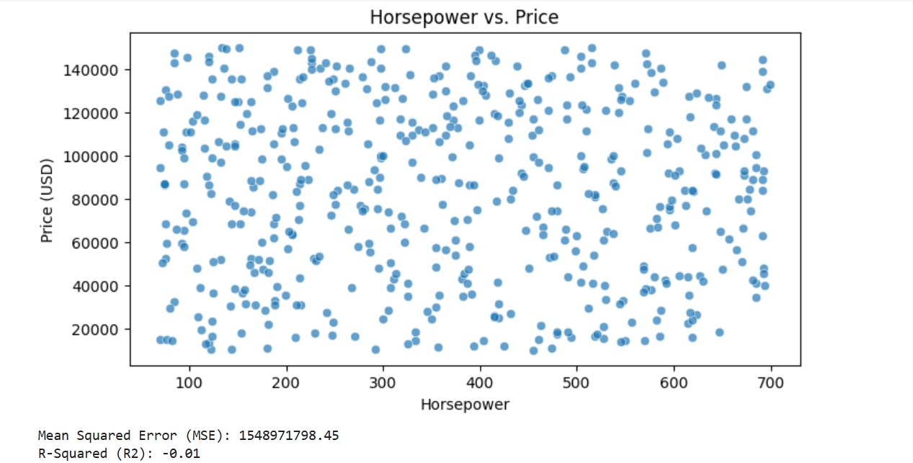

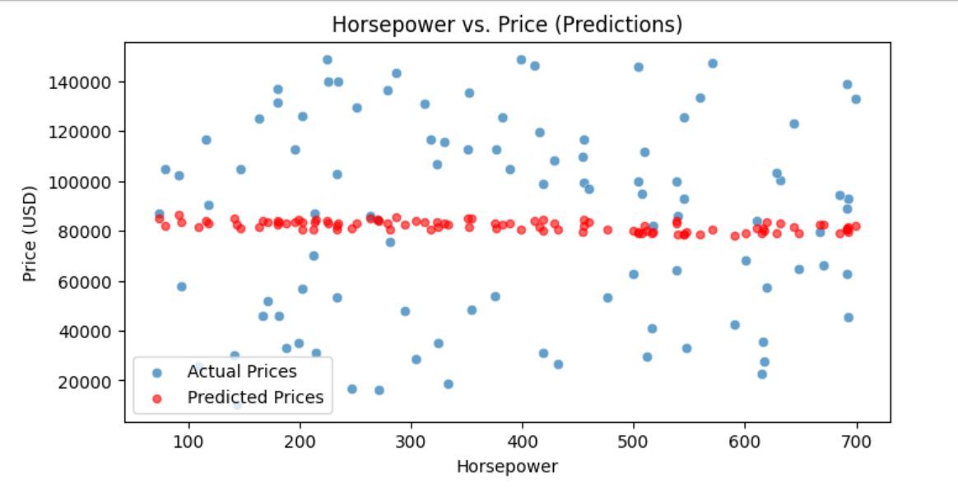

Dataset:

|  |  |  |  |  |  |  |  |
| --- | --- | --- | --- | --- | --- | --- | --- |
| CarID | Engine_Size_L | Horsepower | Fuel_Efficiency_MPG | Weight_lbs | Cylinders | Year | Price_USD |
| 1 | 3.1 | 571 | 49 | 3058 | 8 | 2017 | 147215.3 |
| 2 | 6.2 | 214 | 41.2 | 2197 | 4 | 2017 | 76902.98 |
| 3 | 5 | 270 | 14.6 | 4532 | 4 | 1997 | 84516.05 |
| 4 | 4.3 | 530 | 32.6 | 5828 | 4 | 1998 | 33567.17 |
| 5 | 1.9 | 627 | 49.4 | 3082 | 4 | 2020 | 44567.04 |
| 6 | 1.9 | 616 | 28.8 | 4884 | 12 | 2019 | 127396.9 |
| 7 | 1.3 | 322 | 17.3 | 3184 | 6 | 2009 | 59865.99 |
| 8 | 5.8 | 459 | 29.4 | 3008 | 10 | 2000 | 125754.1 |
| 9 | 4.3 | 663 | 30.5 | 4738 | 6 | 2009 | 109261.9 |
| 10 | 4.9 | 325 | 39.7 | 3229 | 6 | 2015 | 34803.93 |
| 11 | 1.1 | 519 | 38 | 3035 | 4 | 1997 | 81042.49 |
| 12 | 6.3 | 79 | 26.1 | 2489 | 6 | 2019 | 104834.2 |
| 13 | 5.6 | 311 | 18.7 | 2275 | 4 | 2015 | 42905.21 |
| 14 | 2.2 | 320 | 35.8 | 4740 | 8 | 2015 | 126296.4 |
| 15 | 2 | 74 | 26.9 | 4289 | 8 | 2008 | 86275.87 |
| 16 | 2 | 188 | 15.3 | 3239 | 4 | 2014 | 33133.89 |
| 17 | 2.7 | 443 | 46 | 3274 | 12 | 2008 | 91617.82 |
| 18 | 3.9 | 134 | 37.6 | 5882 | 8 | 1998 | 149959.9 |
| 19 | 3.4 | 215 | 37.3 | 2125 | 6 | 2006 | 31073.01 |
| 20 | 2.6 | 293 | 42.9 | 2216 | 4 | 2011 | 124346 |
| 21 | 4.4 | 308 | 31.2 | 5377 | 6 | 2001 | 39023.26 |
| 22 | 1.8 | 246 | 42.6 | 5868 | 6 | 2003 | 119534.4 |
| 23 | 2.6 | 351 | 29.9 | 3208 | 4 | 1997 | 112840.9 |
| 24 | 3 | 132 | 12.7 | 5110 | 4 | 2022 | 52068.51 |
| 25 | 3.5 | 286 | 26.2 | 3246 | 8 | 2007 | 55615.24 |
| 26 | 5.3 | 530 | 29.9 | 5255 | 4 | 2009 | 120953 |
| 27 | 2.1 | 679 | 38.8 | 4542 | 6 | 2012 | 74602.37 |
| 28 | 3.8 | 174 | 14.3 | 4474 | 10 | 2013 | 112314.5 |
| 29 | 4.3 | 168 | 15.6 | 5249 | 8 | 1995 | 30717.78 |
| 30 | 1.3 | 580 | 20.5 | 2918 | 4 | 2000 | 129358.1 |
| 31 | 4.3 | 454 | 20.7 | 5499 | 8 | 2021 | 109523.9 |
| 32 | 1.9 | 474 | 39.3 | 3317 | 4 | 2021 | 136972 |
| 33 | 1.4 | 587 | 20 | 5923 | 4 | 2017 | 28532.13 |
| 34 | 6.2 | 545 | 35.3 | 4198 | 6 | 2021 | 93022.03 |
| 35 | 6.3 | 506 | 29.8 | 4431 | 4 | 2021 | 93876.88 |
| 36 | 5.4 | 92 | 32.9 | 3661 | 4 | 1996 | 59484.5 |
| 37 | 2.7 | 634 | 43.5 | 5884 | 6 | 2018 | 74185.3 |
| 38 | 1.5 | 527 | 26.2 | 2307 | 4 | 2008 | 15317.42 |
| 39 | 4.8 | 152 | 40.8 | 3359 | 4 | 2000 | 114420.4 |
| 40 | 3.4 | 214 | 26.9 | 3969 | 6 | 2008 | 86905.15 |
| 41 | 1.7 | 154 | 24.2 | 4793 | 8 | 1998 | 18083.75 |
| 42 | 3.7 | 147 | 48.3 | 2891 | 6 | 2015 | 105305.8 |
| 43 | 1.2 | 526 | 17.4 | 2374 | 4 | 2002 | 75349.49 |
| 44 | 6 | 70 | 13.6 | 5079 | 6 | 2024 | 14824.58 |
| 45 | 2.4 | 120 | 40.8 | 4033 | 4 | 1997 | 145745.1 |
| 46 | 4.6 | 515 | 12.7 | 3364 | 4 | 2013 | 142875.7 |
| 47 | 2.7 | 518 | 43.5 | 2128 | 8 | 2024 | 81806.34 |
| 48 | 3.9 | 557 | 27.5 | 3014 | 4 | 2008 | 23114.14 |
| 49 | 4 | 103 | 46.6 | 3799 | 4 | 2021 | 115647 |
| 50 | 2 | 417 | 38.9 | 4716 | 6 | 2014 | 78870.35 |
| 51 | 6.3 | 164 | 34.4 | 5423 | 6 | 2011 | 52342.65 |
| 52 | 5.3 | 141 | 48 | 3381 | 6 | 2019 | 78798.54 |
| 53 | 6.2 | 620 | 25.9 | 2516 | 4 | 2002 | 83142.18 |
| 54 | 5.9 | 223 | 48.2 | 3518 | 4 | 2018 | 88779.64 |
| 55 | 4.3 | 319 | 15.4 | 2085 | 4 | 2008 | 71771.32 |
| 56 | 6.1 | 507 | 29.4 | 3198 | 4 | 2020 | 94805.74 |
| 57 | 1.5 | 187 | 20.8 | 5873 | 6 | 2000 | 138622.9 |
| 58 | 2.1 | 375 | 31.6 | 5264 | 8 | 2017 | 60717.53 |
| 59 | 1.2 | 337 | 16.5 | 4358 | 8 | 2016 | 111600.3 |
| 60 | 2.8 | 123 | 43.7 | 3142 | 8 | 2010 | 135223.4 |
| 61 | 3.1 | 305 | 43.9 | 5289 | 6 | 2019 | 73837.1 |
| 62 | 2.5 | 458 | 48.2 | 4474 | 6 | 2013 | 72083.82 |
| 63 | 5.6 | 470 | 16.2 | 3993 | 4 | 2008 | 94296.38 |
| 64 | 3 | 693 | 34.9 | 5485 | 6 | 2013 | 92796.95 |
| 65 | 2.5 | 372 | 29 | 4161 | 6 | 1997 | 122922.5 |
| 66 | 4 | 276 | 23.8 | 5216 | 4 | 2004 | 76707.67 |
| 67 | 1.8 | 298 | 24.1 | 5609 | 4 | 2013 | 149457.2 |
| 68 | 5.4 | 647 | 26.5 | 5719 | 12 | 2003 | 18326.02 |
| 69 | 1.4 | 144 | 38.2 | 2302 | 4 | 2022 | 10443.5 |
| 70 | 6.4 | 504 | 33.9 | 4791 | 4 | 2014 | 99627.76 |
| 71 | 5.2 | 172 | 28.4 | 5952 | 6 | 2007 | 51780.89 |
| 72 | 2.1 | 491 | 13 | 2587 | 8 | 2001 | 43653.53 |
| 73 | 1 | 375 | 13.1 | 2986 | 6 | 2008 | 53665.87 |
| 74 | 5.5 | 167 | 10.1 | 3863 | 6 | 2003 | 45846.66 |
| 75 | 4.9 | 404 | 48.7 | 2344 | 4 | 2021 | 14310.61 |
| 76 | 5 | 504 | 10.2 | 2813 | 6 | 2022 | 146014.6 |
| 77 | 5.2 | 516 | 14.1 | 3987 | 4 | 2017 | 40904.37 |
| 78 | 1.4 | 377 | 22.6 | 4848 | 8 | 2019 | 112764.2 |
| 79 | 3 | 318 | 42.3 | 5072 | 6 | 2022 | 116763.5 |
| 80 | 1.6 | 235 | 48.5 | 5218 | 4 | 2013 | 140096 |
| 81 | 5.7 | 550 | 41.6 | 3310 | 4 | 2009 | 14276.92 |
| 82 | 4.4 | 404 | 37.6 | 3999 | 4 | 2014 | 132086.8 |
| 83 | 2.8 | 611 | 30.9 | 3677 | 4 | 2008 | 83811.67 |
| 84 | 1.3 | 175 | 13.5 | 5124 | 4 | 2018 | 98556.18 |
| 85 | 2.7 | 632 | 48.3 | 3327 | 6 | 2000 | 100225.8 |
| 86 | 2.8 | 150 | 40.3 | 3092 | 6 | 2015 | 124771.7 |
| 87 | 5 | 202 | 35.6 | 4408 | 4 | 2023 | 56677.03 |
| 88 | 4.5 | 207 | 40.4 | 5673 | 4 | 1998 | 112627.2 |
| 89 | 5.9 | 253 | 39 | 5291 | 4 | 2002 | 84000.94 |
| 90 | 3.6 | 470 | 35.5 | 3009 | 8 | 2011 | 121075.2 |
| 91 | 1.7 | 399 | 49.2 | 2703 | 4 | 2024 | 148676.4 |
| 92 | 4.9 | 577 | 46.1 | 2574 | 6 | 2003 | 38091.14 |
| 93 | 5.2 | 138 | 35.9 | 3608 | 8 | 1995 | 149250.8 |
| 94 | 4.1 | 615 | 37.7 | 5232 | 6 | 2018 | 22573.7 |
| 95 | 5.2 | 122 | 12.1 | 5752 | 8 | 2014 | 10324.46 |
| 96 | 3.7 | 519 | 36.8 | 3112 | 4 | 2019 | 16182.67 |
| 97 | 3.9 | 274 | 11.8 | 2687 | 12 | 2008 | 57849.54 |
| 98 | 3.4 | 195 | 33.5 | 4828 | 4 | 2005 | 98606.89 |
| 99 | 1.1 | 112 | 50 | 4632 | 4 | 2015 | 19664.14 |
| 100 | 1.6 | 180 | 32.2 | 5828 | 6 | 1997 | 10793.21 |
| 101 | 1.2 | 252 | 28.9 | 4636 | 10 | 2003 | 141192.7 |
| 102 | 4.5 | 164 | 22.5 | 5230 | 8 | 2021 | 125069.7 |
| 103 | 2.7 | 443 | 14.8 | 2488 | 4 | 2008 | 123285.6 |
| 104 | 3.8 | 589 | 39.2 | 5018 | 4 | 2024 | 133819.4 |
| 105 | 6 | 429 | 17.7 | 3347 | 10 | 2003 | 108004.8 |
| 106 | 2.4 | 350 | 14.6 | 5681 | 4 | 1998 | 24616.58 |
| 107 | 3.3 | 264 | 26.9 | 5452 | 8 | 2021 | 65874.03 |
| 108 | 5.2 | 264 | 41.8 | 5173 | 8 | 1998 | 111240.9 |
| 109 | 2.3 | 162 | 39.8 | 2493 | 6 | 2022 | 49246.82 |
| 110 | 1.4 | 130 | 12.2 | 3667 | 4 | 2002 | 106236.9 |
| 111 | 2.6 | 120 | 28.2 | 3637 | 6 | 1996 | 13429.78 |
| 112 | 1.9 | 472 | 30.9 | 2018 | 4 | 2003 | 52859.23 |
| 113 | 6.1 | 74 | 35.8 | 5525 | 8 | 2023 | 86878.25 |
| 114 | 5.4 | 535 | 36 | 5553 | 6 | 2008 | 98492.58 |
| 115 | 4.5 | 673 | 24.6 | 5665 | 8 | 2016 | 90785.69 |
| 116 | 5.8 | 603 | 32.4 | 4444 | 4 | 2003 | 107685.9 |
| 117 | 5.4 | 474 | 29.2 | 3000 | 12 | 2018 | 10852.42 |
| 118 | 2 | 582 | 45.4 | 5350 | 6 | 2017 | 24131.77 |
| 119 | 5.9 | 302 | 31.2 | 2850 | 4 | 2010 | 131652.2 |
| 120 | 4 | 593 | 27.6 | 3388 | 4 | 2023 | 105444.8 |
| 121 | 5.4 | 415 | 26.2 | 3354 | 8 | 2024 | 25810.43 |
| 122 | 5.9 | 115 | 32.9 | 5712 | 6 | 2011 | 127890.4 |
| 123 | 2.7 | 615 | 42.2 | 3367 | 8 | 2010 | 43912.37 |
| 124 | 1.6 | 147 | 31.5 | 2821 | 4 | 2024 | 76956.38 |
| 125 | 2.3 | 142 | 36.5 | 2454 | 4 | 2006 | 30327.51 |
| 126 | 3.3 | 318 | 39.5 | 3624 | 6 | 1997 | 109415.4 |
| 127 | 5.5 | 116 | 30.8 | 4772 | 4 | 2005 | 103359.6 |
| 128 | 5.7 | 190 | 27.1 | 5726 | 6 | 2008 | 39555.75 |
| 129 | 1 | 283 | 45.1 | 5136 | 12 | 2012 | 130876.1 |
| 130 | 3.8 | 308 | 26.7 | 5147 | 12 | 2015 | 66182.84 |
| 131 | 3.3 | 125 | 28.5 | 2710 | 10 | 2015 | 50952.11 |
| 132 | 2.2 | 419 | 49.6 | 4190 | 8 | 1999 | 31326.14 |
| 133 | 1.7 | 176 | 10 | 2916 | 4 | 2010 | 47263.52 |
| 134 | 2.9 | 117 | 17.4 | 5986 | 6 | 2014 | 13083.77 |
| 135 | 6.2 | 642 | 25.4 | 4875 | 6 | 1999 | 91656.05 |
| 136 | 2.8 | 406 | 47.3 | 4652 | 8 | 1997 | 127912.3 |
| 137 | 3.9 | 95 | 12.8 | 3496 | 4 | 2006 | 86857.26 |
| 138 | 4.9 | 326 | 10.4 | 3440 | 6 | 1995 | 40698.35 |
| 139 | 3 | 77 | 12.1 | 2304 | 4 | 2015 | 14713.68 |
| 140 | 6.3 | 694 | 13.5 | 2735 | 6 | 2023 | 40047.93 |
| 141 | 6.3 | 322 | 11.5 | 5568 | 8 | 2003 | 68257 |
| 142 | 2.4 | 372 | 29.2 | 4338 | 8 | 2023 | 116345.6 |
| 143 | 3.7 | 125 | 33.2 | 3963 | 4 | 2003 | 36298 |
| 144 | 2.7 | 595 | 20.9 | 4149 | 12 | 1998 | 110770.8 |
| 145 | 2.6 | 543 | 25.9 | 4009 | 6 | 1997 | 131370.7 |
| 146 | 1.2 | 97 | 13.7 | 5338 | 4 | 2011 | 73552.56 |
| 147 | 4.4 | 147 | 23.5 | 4914 | 4 | 1996 | 125000.5 |
| 148 | 3.8 | 285 | 30.9 | 5015 | 4 | 2018 | 87652.03 |
| 149 | 1.3 | 455 | 39.3 | 5693 | 4 | 1995 | 99192.72 |
| 150 | 2.5 | 434 | 10.1 | 5021 | 12 | 2002 | 83678.98 |
| 151 | 6 | 595 | 28.7 | 4889 | 6 | 2007 | 74844.18 |
| 152 | 2.3 | 381 | 21.9 | 2961 | 8 | 2017 | 42851.48 |
| 153 | 1.8 | 76 | 44.1 | 4989 | 4 | 2009 | 52447.17 |
| 154 | 3.7 | 72 | 38.6 | 5848 | 4 | 2002 | 50595.82 |
| 155 | 6.4 | 692 | 33.6 | 3026 | 6 | 2006 | 88860.45 |
| 156 | 2.3 | 432 | 21.1 | 4132 | 4 | 2016 | 26793.52 |
| 157 | 4.7 | 577 | 46.4 | 5865 | 6 | 2006 | 138350.8 |
| 158 | 5.2 | 343 | 11.8 | 4375 | 10 | 2008 | 110891.7 |
| 159 | 2.3 | 575 | 14.4 | 4863 | 6 | 2009 | 66202.39 |
| 160 | 5 | 84 | 25.7 | 3473 | 6 | 2009 | 32207.38 |
| 161 | 3 | 261 | 15 | 4501 | 4 | 2003 | 133478.9 |
| 162 | 4.5 | 554 | 48.3 | 3947 | 4 | 2013 | 125328.9 |
| 163 | 4.5 | 97 | 41.9 | 4676 | 4 | 2020 | 111041 |
| 164 | 3.9 | 108 | 20.4 | 5292 | 6 | 2014 | 48016.59 |
| 165 | 1.5 | 342 | 33.5 | 3177 | 4 | 2023 | 66342.53 |
| 166 | 5.6 | 300 | 49.3 | 2664 | 4 | 2016 | 24384.76 |
| 167 | 2.8 | 155 | 45.4 | 2011 | 6 | 2002 | 36465.53 |
| 168 | 2 | 543 | 34 | 3156 | 4 | 2015 | 119622.3 |
| 169 | 1.2 | 195 | 46.1 | 2303 | 4 | 2013 | 110105.4 |
| 170 | 4.2 | 606 | 49.6 | 5364 | 4 | 2000 | 93088.01 |
| 171 | 4.7 | 214 | 39.7 | 5022 | 10 | 2014 | 135401.7 |
| 172 | 1.1 | 594 | 12.6 | 5371 | 6 | 2019 | 91657.31 |
| 173 | 3.8 | 281 | 26.1 | 3763 | 6 | 2023 | 75375.52 |
| 174 | 2.2 | 94 | 43.5 | 4830 | 4 | 2013 | 57651.9 |
| 175 | 4.5 | 649 | 19.2 | 2042 | 12 | 1998 | 141662.8 |
| 176 | 2 | 463 | 43.2 | 2943 | 6 | 2017 | 21580.16 |
| 177 | 4.8 | 136 | 14.8 | 4390 | 4 | 2001 | 140324.2 |
| 178 | 3.1 | 302 | 11.9 | 3349 | 8 | 2022 | 125740.1 |
| 179 | 6.2 | 178 | 25.4 | 5885 | 4 | 2022 | 28190.19 |
| 180 | 1.8 | 215 | 11.5 | 4545 | 6 | 1998 | 89097.81 |
| 181 | 2.9 | 180 | 48.3 | 4411 | 6 | 2016 | 131316.7 |
| 182 | 1.6 | 297 | 43 | 2890 | 4 | 2006 | 90053.28 |
| 183 | 6.1 | 180 | 42 | 4474 | 12 | 2007 | 137008 |
| 184 | 5.8 | 539 | 35.2 | 3004 | 8 | 1997 | 142017.7 |
| 185 | 2.4 | 103 | 18.7 | 2020 | 6 | 2016 | 69133.83 |
| 186 | 4.6 | 692 | 30.7 | 2406 | 4 | 2006 | 62823.91 |
| 187 | 5.5 | 438 | 33.9 | 4666 | 4 | 1996 | 141085 |
| 188 | 4.1 | 664 | 31 | 3014 | 4 | 2018 | 104519.6 |
| 189 | 3.9 | 623 | 20.4 | 2335 | 8 | 1996 | 26243.18 |
| 190 | 2.3 | 494 | 30.6 | 3838 | 4 | 2021 | 15920.84 |
| 191 | 1.5 | 682 | 29.6 | 5188 | 6 | 2017 | 89048.07 |
| 192 | 5.9 | 587 | 49.9 | 3147 | 8 | 2003 | 140223.9 |
| 193 | 6 | 351 | 45.9 | 4446 | 4 | 1995 | 128194.8 |
| 194 | 4.5 | 389 | 28.5 | 4840 | 6 | 2002 | 104618.7 |
| 195 | 2.9 | 512 | 34.9 | 3827 | 4 | 2017 | 29476.22 |
| 196 | 2.9 | 384 | 39.9 | 2714 | 12 | 2000 | 45592.39 |
| 197 | 5 | 446 | 11.4 | 2050 | 6 | 2000 | 132571.6 |
| 198 | 5.9 | 358 | 45.8 | 5854 | 4 | 2016 | 35593.01 |
| 199 | 5.9 | 506 | 44.4 | 2323 | 4 | 2019 | 48981.52 |
| 200 | 5.3 | 346 | 28.3 | 2788 | 6 | 2012 | 28144.09 |
| 201 | 4.5 | 651 | 25.6 | 2140 | 8 | 2011 | 104655.2 |
| 202 | 1.5 | 572 | 20.9 | 2469 | 8 | 2023 | 142157.5 |
| 203 | 1.9 | 693 | 29.1 | 2786 | 6 | 2006 | 47655.52 |
| 204 | 5.9 | 585 | 11.8 | 3825 | 4 | 2000 | 76556.93 |
| 205 | 4.3 | 419 | 44.1 | 3357 | 4 | 2020 | 98807.56 |
| 206 | 1.1 | 515 | 11.4 | 3916 | 4 | 2021 | 149925.3 |
| 207 | 1.6 | 419 | 23.2 | 2963 | 6 | 2002 | 24673.13 |
| 208 | 4.6 | 676 | 47.3 | 5055 | 8 | 2013 | 79799.91 |
| 209 | 1 | 206 | 39.4 | 2372 | 6 | 2022 | 63916.82 |
| 210 | 1.9 | 312 | 21.3 | 5635 | 4 | 2004 | 131214.8 |
| 211 | 4 | 612 | 20.1 | 4541 | 6 | 1995 | 76635.48 |
| 212 | 4.8 | 109 | 10.2 | 5610 | 8 | 2019 | 25536.85 |
| 213 | 4.6 | 298 | 37.8 | 3692 | 8 | 2023 | 98819.38 |
| 214 | 2.2 | 617 | 12 | 4798 | 8 | 2007 | 117909.3 |
| 215 | 4.9 | 292 | 31.3 | 3179 | 4 | 2011 | 10403.38 |
| 216 | 2.3 | 75 | 48.5 | 4338 | 4 | 1997 | 130253.9 |
| 217 | 2.8 | 391 | 14.4 | 3671 | 8 | 2002 | 36043.22 |
| 218 | 5.1 | 537 | 45.8 | 5215 | 6 | 2008 | 87289.71 |